Cairo University Faculty of Computers and Information



**Advanced Software Engineering**

**Daily scrum meeting template**

**2020/2021**

**Project Team**

|  |  |  |  |
| --- | --- | --- | --- |
| **ID** | **Name** | **Email** | **Mobile** |
| 20180075 | Tawfik Yasser Tawfik | tawfekyassertawfek@gmail.com | 01129348206 |
| 20180051 | Alamir Hassan Younis | alamirhassan8@gmail.com | 01127171631 |
| 20180279 | Mostafa adel mohamed | Mostafahutler6@gmail.com | 01005524395 |
| 20180229 | Muhammad Abdullah Aboud | maboud229@gmail.com | 01143837355 |

Title page has no header or footer.

Docs must be supplied as pdf –files re-named as requested

Contents

Instructions [To be removed] **Error! Bookmark not defined.**

Done requirements 2

What will be done today 2

Current obstacles **Error! Bookmark not defined.**

Current Trello workspace 6

# Done requirements

## Tawfik Yasser Tawfik

1. Part of the class diagram.
2. Sequence Diagram for Update function.
3. SignUp and in class Website and Update in class CRUD.

## Alamir Hassan Younis

1. Part of the class diagram.
2. Sequence Diagram for Create function.
3. Login in class Website and Read in class CRUD.

## Muhammad Abdullah Aboud

1. Part of the class diagram.
2. Sequence Diagram for Read function.
3. Delete in class CRUD and Notification Class.

## Mostafa Adel Mohamed

1. Part of the class diagram.
2. Sequence Diagram for Delete function.
3. Create in class CRUD and User Class.

# What will be done today

## Tawfik Yasser Tawfik

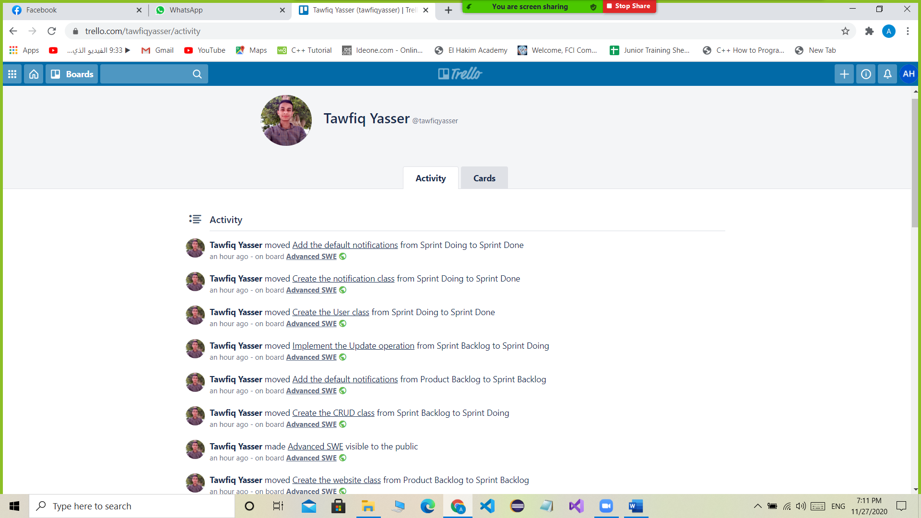

## Alamir Hassan Younis

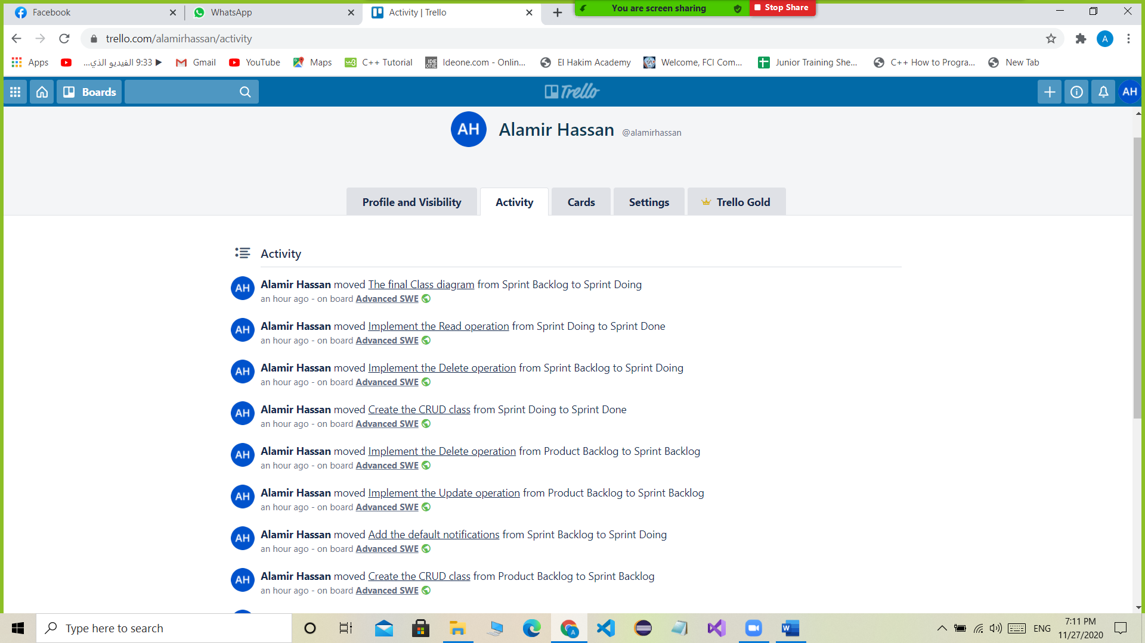

## Muhammad Abdullah Aboud

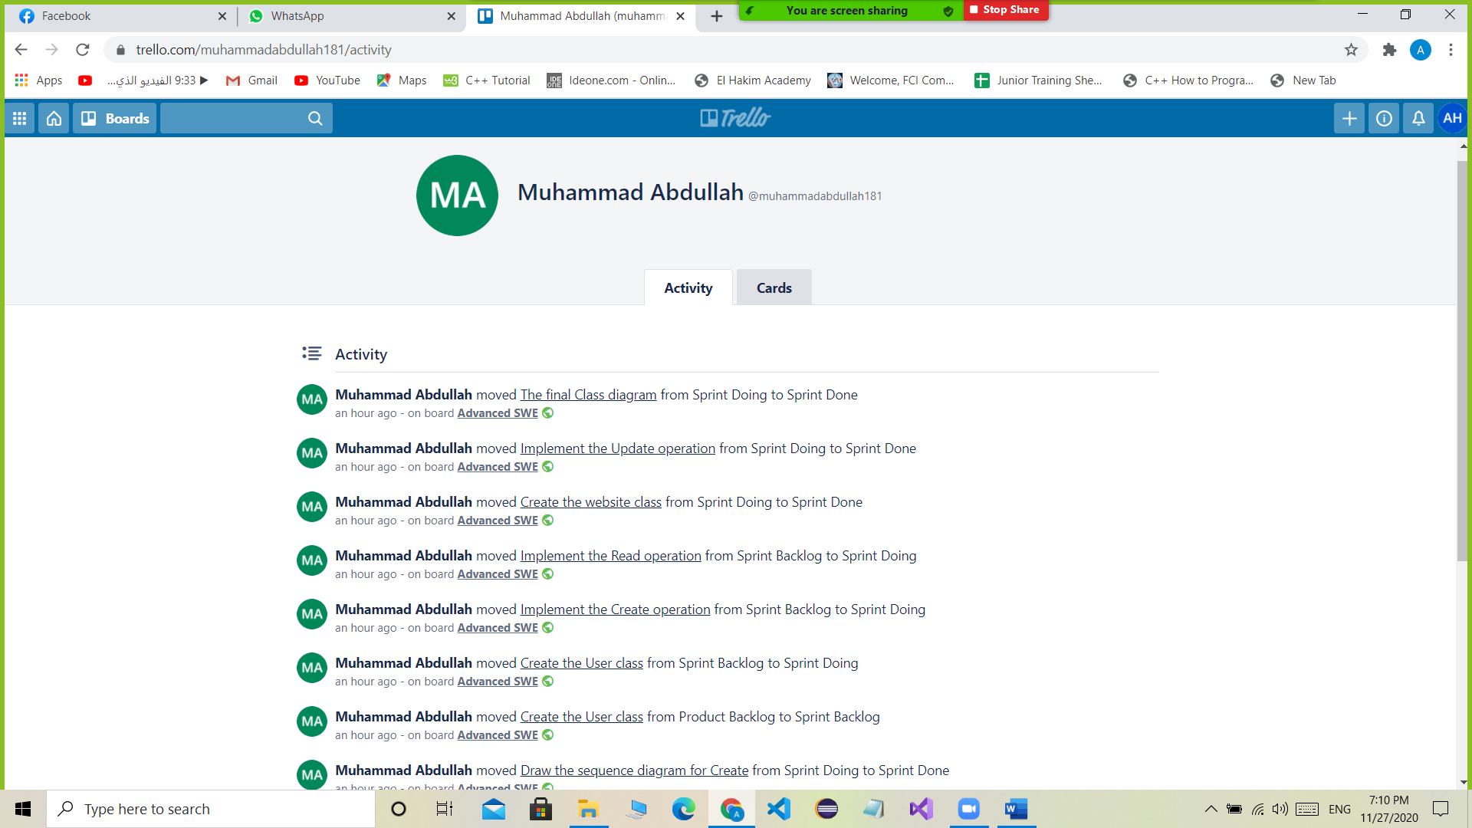

## Mostafa Adel Mohamed

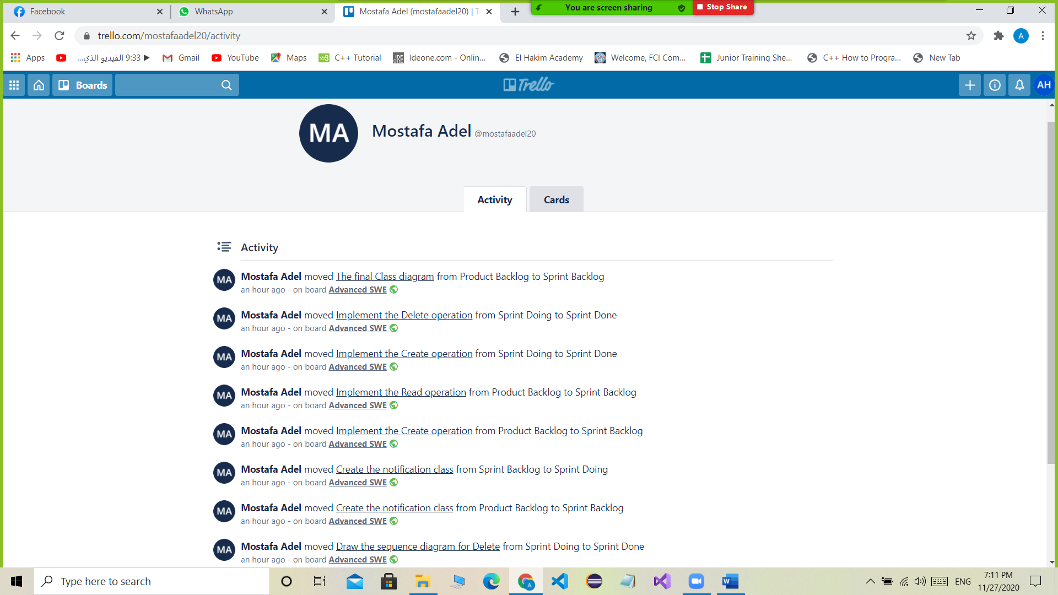

# Current Trello workspace

